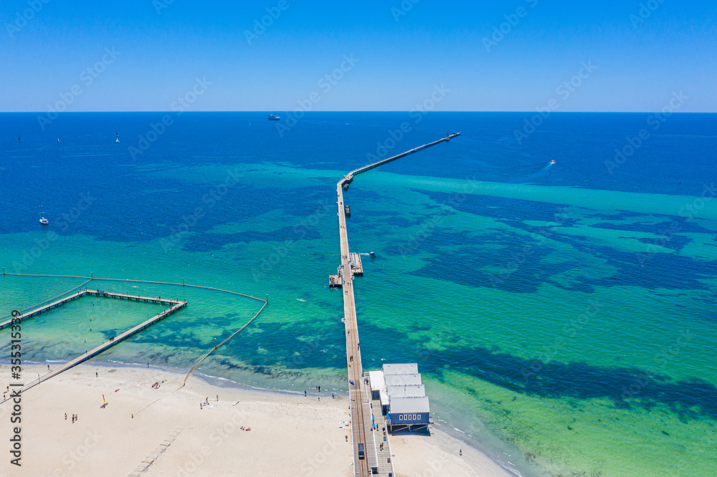

**2025 ANNUAL GATHERING OF MOONEYS**

**BUSSELTON, WA**

**MARCH 13 – 17 2025**

Click or tap to enter. Click or tap to enter.

Click or tap to enter. Click or tap to enter.

Click or tap to enter. Click or tap to enter.

Click or tap to enter.

I am interested in joining a Mooney Caravan to YBLN YES  NO

I am interested in fly-on north YES  NO

# **REGISTRATION FEE**

Click or tap to enter. @ $480 PER PERSON = $ Click or tap to enter.

Includes airport transfers, bus travel, bay cruise, tours and some meals.

# **PAYMENT VIA DIRECT DEPOSIT**

AUSTRALIAN MOONEY PILOTS ASSOC. BSB: 035047 ACC: 156723

In the "details to payee" field, please put your **surname** first, followed by **AGM**"

PLEASE SUBMIT COMPLETED FORMS TO [***events@mooney.org.au***](mailto:events@mooney.org.au)by ***11 February 2025***