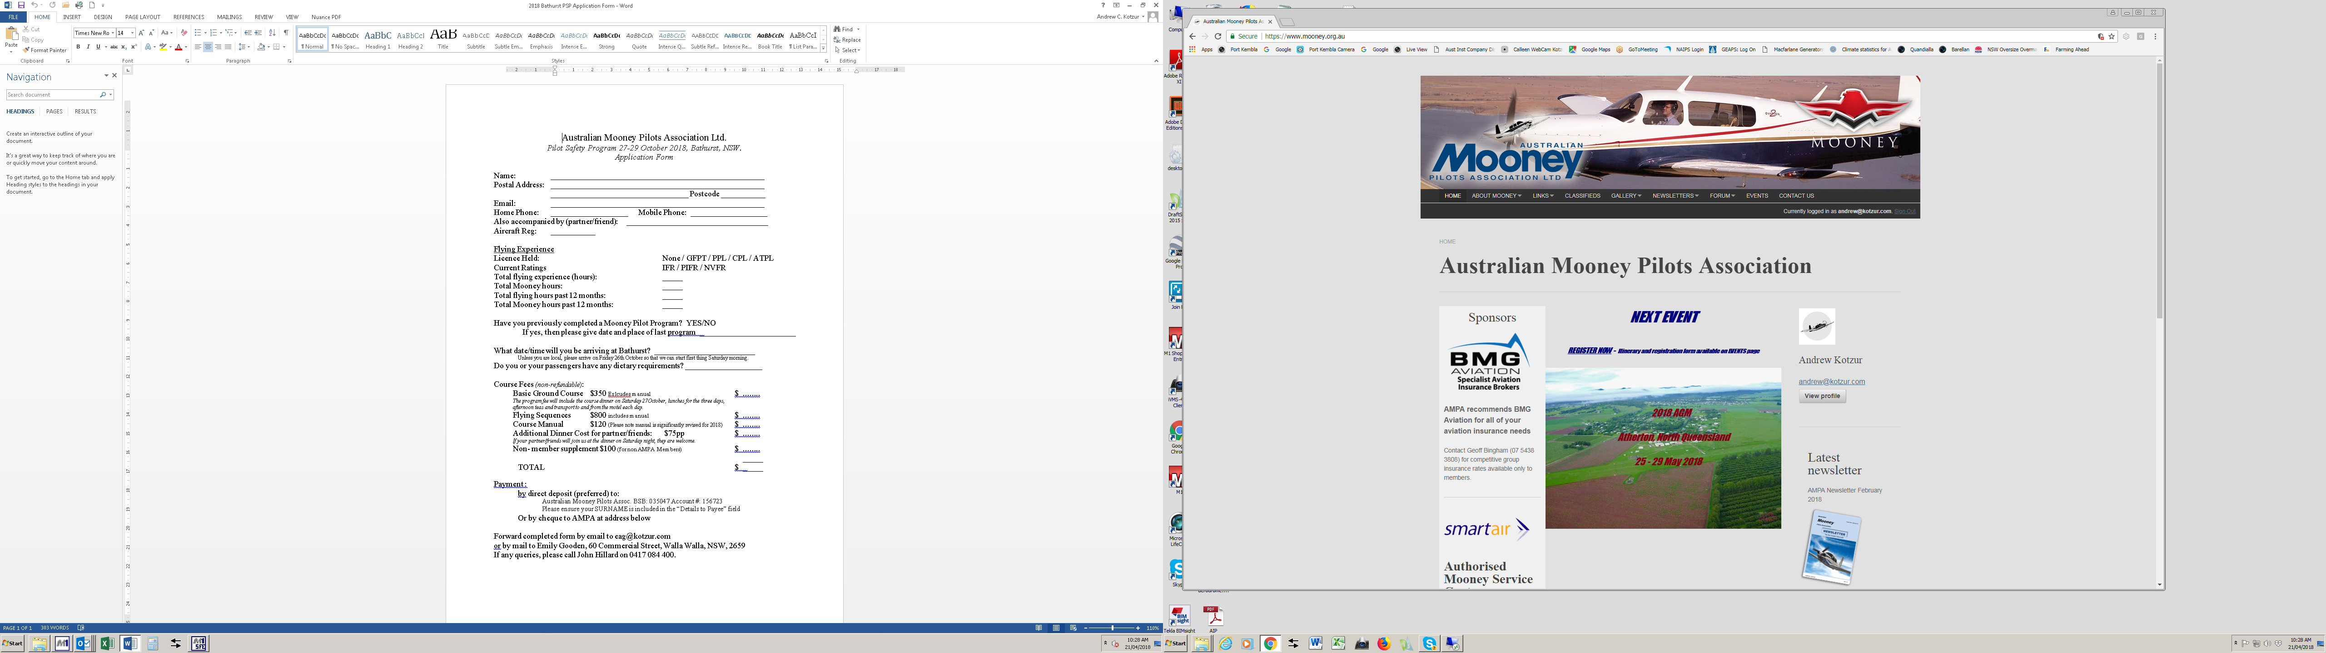

Australian Mooney Pilots Association Ltd.

*Pilot Safety Program 11-13 October 2024, Jandakot, WA.*

**Application Form**

Name: _____________________________________________________

Postal Address: _____________________________________________________

__________________________________ Postcode ___________

Email: _____________________________________________________

Home Phone: ___________________ Mobile Phone: ___________________

Also accompanied by (partner/friend): ___________________________________

Aircraft Reg: ___________

Licence Held: RPL / PPL / CPL / ATPL

Current Ratings IFR / PIFR / NVFR

Total flying experience (hours): _____ Mooney hours:_____

Flying hours (past 12 months): _____ Mooney hours (past 12 months): _____

Have you previously completed a Mooney Pilot Program? YES/NO

If yes, then please give date and place of last program ________________________

What date/time will you be arriving at Jandakot? _________________________

*Unless you are local, please arrive on Thursday 10th October so that we can start first thing Friday morning.*

Do you or your partner/passengers have any dietary requirements? ___________________

Course Fees *(non-refundable*):

Basic Ground Course $450 Excludes manual $ ........

*The program fee will include the course dinner, lunches for the three days, morning and afternoon teas, and transport to and from the motel each day.*

Flying Sequences $225 (1/2 price) $ ........

Course Manual (2018 edition) $120 $ ........

Additional Dinner Cost for partner/friends: $85pp $ ........

*If your partner/friends will join us at the dinner on Saturday night, they are welcome.*

Non- member supplement $100 (for non AMPA Members) $ ........

_______

TOTAL $ _____

Payment : Direct deposit (preferred); Australian Mooney Pilots Assoc.

BSB: 035047 Account #: 156723

By June 30th to secure your place. Please ensure your SURNAME is included in the “Details to Payee” field

Forward completed form by email to psp@mooney.org.au

If any queries, please call Stuart Payne on 0409 397139